IVDD 98/79/EC

Directive of the European Parliament and of the Council on in Vitro Diagnostic Medical Devices

For all IVDs, except Class 1 IVDs and Class 1, 2 and 3 in-house IVDs, the sponsor must submit Manufacturer's Evidence before applying to include the IVD in the EU AREA.
the following certificates as Manufacturer's Evidence:
- a Conformity Assessment Certificate for Schedule 3 Part 1 (Full quality assurance) or Schedule 3 Part 4 (Production quality assurance) of the Therapeutic Goods (Medical Devices) Regulations 2002- this is mandatory for some manufacturers and IVDs in some classes
- an EC certificate issued by an EU Notified Body for Annex IV.3 (Full quality assurance) or Annex VII (Production quality assurance) of the EU IVDD 98/79/EC
- an ISO 13485 Medical devices -- Quality management systems -- Requirements for regulatory purposes compliance certificate issued by a:
  - a certification body that is also a Notified Body for the purposes of the IVDD 98/79/EC
  - CMDCAS (Canadian Medical Devices Conformity Assessment System) recognised Registrar
  - a certification body that is accredited by a signatory of the International Accreditation Forum (IAF) Multilateral Recognition Arrangement (MLA) to perform ISO 13485 certification.

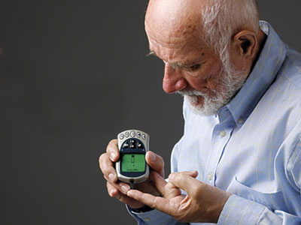
The following table provides the parallel references for the EU conformity assessment procedures:
Therapeutic Goods (Medical Devices) Regulations 2002 | EU reference  IVDD 98/79/EC
Schedule 3 Part 1 - Full quality assurance procedures | Annex IV
Schedule 3 Part 1, Clause 1.6 - Examination of design of Class 4 IVD medical device and Class 4 In-house IVD medical device | Annex IV.4
Schedule 3 Part 2 - Type examination procedures | Annex V
Schedule 3 Part 4 - Production quality assurance procedures | Annex VII
Schedule 3 Part 6 - Declaration of conformity procedures | Annex III
For some Class 2 and 3 IVDs covered by EC Certificates a mandatory application audit (technical file review) will be conducted once the sponsor lodges an application .
The application audit is to confirm that the manufacturer of an IVD has carried out conformity assessment procedures appropriate to the classification of the device.

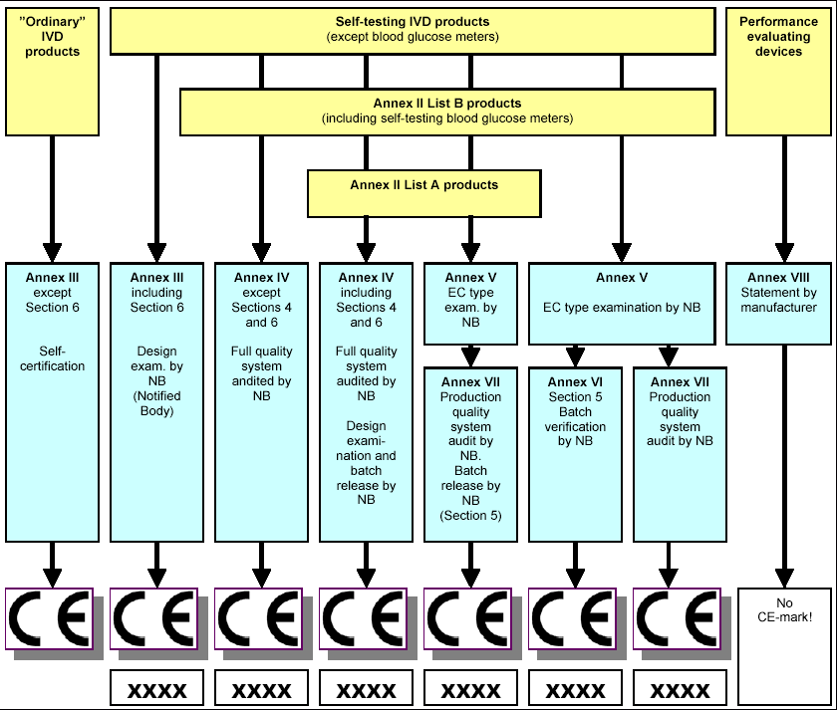

For each class of IVD there are restrictions on type of certificates that may be used to demonstrate that a manufacturer has the appropriate manufacturing processes to make the IVD (Manufacturer's Evidence). These are shown on the following table.
Certificate issued under | Certificate type | Allowable Class of IVD
Therapeutic Goods (Medical Devices) Regulations | Schedule 3 Part 1  (Full Quality Assurance) | Class 4 IVD  Class 4 in-house IVD  Class 3 IVD  Class 2 IVD
 | Schedule 3 Part 4  (Production Quality Assurance) | Class 4 IVD  Class 4 in-house IVD  Class 3 IVD  Class 2 IVD
Directive 98/79/EC (IVDD)  (EU Notified Body) | Annex IV.3  (Full Quality Assurance) | Class 3 IVD  Class 2 IVD
 | Annex VII  (Production Quality Assurance) | Class 3 IVD  Class 2 IVD
ISO 13485  (CMDCAS recognised Registrar) | ISO 13485 Manufacturing and Design | Class 3 IVD  Class 2 IVD
 | ISO 13485 Manufacturing excluding Design | Class 2 IVD
ISO 13485  (certification body accredited by signatory of IAF MLA or a certification body that is also an EU Notified Body) | ISO 13485 | Class 3 IVD  Class 2 IVD

What is a Technical File?
A technical file represents all the information that is held by a manufacturer in relation to a particular IVD. The documentation is normally an output of the manufacturer's quality management system, and includes information generated throughout the design, development, production and monitoring phases of the IVD. Information may be held across a number of locations or in different forms, and various components from the technical file can be used to demonstrate conformity to the Essential Principles of safety and performance.

The depth and detail of the information contained in the STED is primarily dependent on the risk classification of the IVD, however consideration should also be given to the complexity of the IVD and whether it incorporates the detection or measurement of a new analyze, any new technology or a new clinical application.

